Studio

UNIT 3

SQ FT 574

FLOOR 7-31


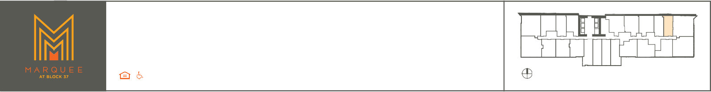
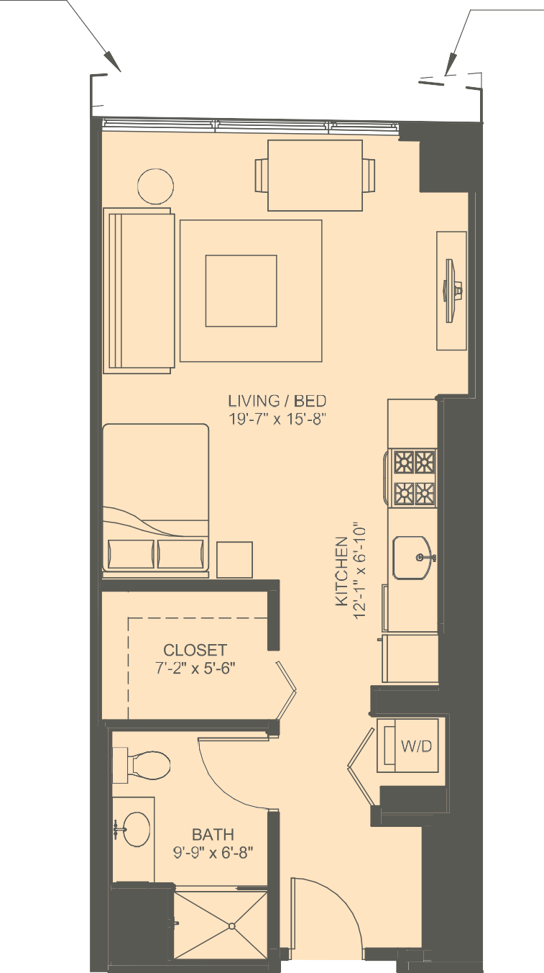

A 606 SQ FT
703, 803, 1603,
1703, 1803, 2803,
2903, 3003

B 595 SQ FT
1103, 1203, 1303,
2203, 3103,

All dimensions and square footages are approximate and plans are not to scale. Designs, materials and specifications are subject to architectural, structural and other revisions as they are deemed necessary by the developer, builder or architect, or as may be required by law. The developer reserves the right to
make modifications in pricing, scheduling and delivering of residences without prior notice.

